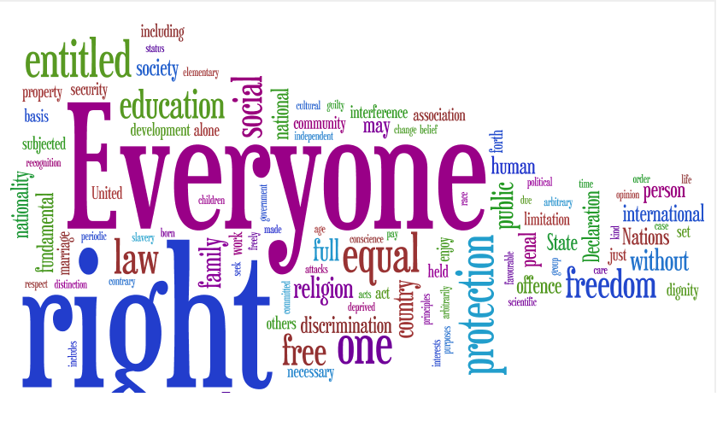
2018-19

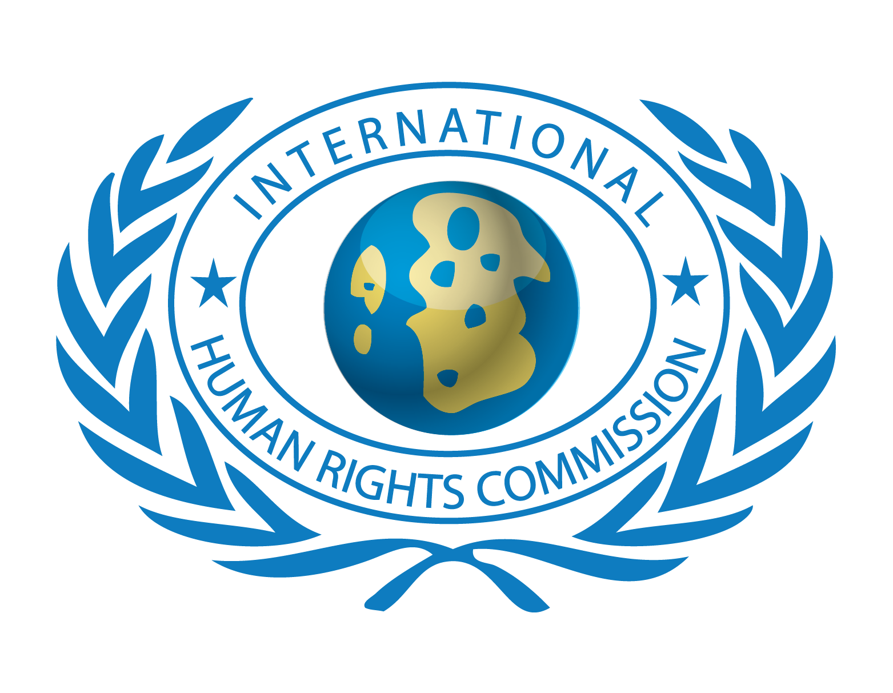
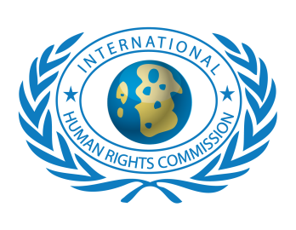

COMPLIED BY DEPARTMENT OF PUBLIC INFORMATION P A G E | 1
IHRC MEMBERSHIP PROFILE
INTERNATIONAL HUMAN RIGHTS COMMISSION

IHRC MEMBERSHIP PROFILE FOR ORGANIZATIONS
- The International Human Rights Commission is dedicated to protecting the human rights of people around the world and promoting the cultural of Peace among the nations.
- We stand with victims and activists to prevent discrimination, to uphold political freedom, to protect people from inhumane conduct in wartime, and to bring offenders to justice.
- We investigate and expose human rights violations and hold abusers accountable.
- We challenge governments and those who hold power to end abusive practices and respect international human rights law.
- We enlist the public and the international community to support the cause of human rights for all.

APPLICATION FOR NEW MEMBERSHIP

Date submitted:

CURRENT MEMBER PROFILE UPDATE

Year joined IHRC:
Name of Organization:

Acronym of Organization:

Head of the Organization:

Headquarters Address:

Website:

HEADQUARTERS INFORMATION
Name: | Title and function of head of organization:
Street address: | City:
State/Province/Region: | Postal Code:
Country: | E-mail:
Tel (country, city code and number): | Fax (country, city code and number):
Contact person to receive membership invoices and receipts
Name: | Title and function:
Street address: | City:
State/Province/Region: | Postal Code:
Country: | E-mail:
Tel (country, city code and number): | Fax (country, city code and number):
Main contact person to receive IHRC e-news and additional electronic updates
Name: | Title and function:
Street address: | City:
State/Province/Region: | Postal Code:
Country: | E-mail:
Tel (country, city code and number): | Fax (country, city code and number):
REPRESENTATIVES
HQ REPRESENTATIVE
Name: | Title and function:
Street address: | City:
State/Province/Region: | Postal Code:
Country | E-mail:
Tel (country, city code and number): | Fax (country, city code and number):
INTL: SECRETARIAT REPRESENTATIVE
Name: | Title and function:
Street address: | City:
State/Province/Region: | Postal Code:
Country: | E-mail:
Tel (country, city code and number): | Fax (country, city code and number):
DFA REPRESENTATIVE
Name: | Title and function:
Street address: | City:
State/Province/Region: | Postal Code:
Country: | E-mail:
Tel (country, city code and number): | Fax (country, city code and number):
REGIONAL REPRESENTATIVES
Africa Region
Name: | Title and function:
Street address: | City:
State/Province/Region: | Postal Code:
Country: | E-mail:
Tel (country, city code and number): | Fax (country, city code and number):
Europe Region
Name: | Title and function:
Street address: | City:
State/Province/Region: | Postal Code:
Country: | E-mail:
Tel (country, city code and number): | Fax (country, city code and number):
Latin America and the Caribbean Region
Name: | Title and function:
Street address: | City:
State/Province/Region: | Postal Code:
Country: | E-mail:
Tel (country, city code and number): | Fax (country, city code and number):
Western Asia Region
Name: | Title and function:
Street address: | City:
State/Province/Region: | Postal Code:
Country: | E-mail:
Tel (country, city code and number): | Fax (country, city code and number):
Asia and the Pacific Region
Name: | Title and function:
Street address: | City:
State/Province/Region: | Postal Code:
Country: | E-mail:
Tel (country, city code and number): | Fax (country, city code and number):

IHRC MEMBERSHIP CATEGORIES
Full Membership
Full membership is open to all NGOs having Consultative Status with the UN through the Economic and Social Council (ECOSOC) or with the EU, African Union, Arab League, OIC and other Intergovernmental Organization.
Associate Membership
Associate membership is open to all NGOs having formal relationships with the United Nations system - including NGOs affiliated with the Department of Public Information, NGOs accredited to United Nations Conferences, and NGOs accredited to treaty bodies or with the EU, African Union, Arab League, OIC and other Intergovernmental Organization.
Affiliate Membership
Affiliate Membership is open to all those NGOs having registration as the Local or National level under the law of respective countries.
Note: You are kindly requested to attach to this application documentation indicating your organization’s status/affiliation with the United Nations System or any other IGO.
Please check (by double clicking on the check box) below the membership category for which you are applying:
Full member
With IGO’s Consultative Status: General Special Roster
Since (year):
Associate member
List the following:
- UN agency or treaty body affiliated to;
- EU, African Union, Arab League, OIC, GCC, OAS ;
- Any Intergovernmental Organization;
ORGANIZATION’S ACTIVITIES

Types of activity:
Advocacy
Project management
Service delivery
Training
Other:

Geographic Centres of operation:
National Regional International/Multiregional

Thematic areas of expertise (name your top three):
1.
2.
3.
Geographic areas of expertise (name your top three):
1.
2.
3.
IHRC ACTIVITIES
To help us estimate the effectiveness of our communications efforts, please indicate how you first learned about IHRC:
NGO meetings, conferences, events
Website or Social Media Network
IHRC Civil Society Forum
IHRC e-update, newsletter
IHRC Conferences
Other:

Which IHRC activities is your organization interested in?
Dialogue, Outreach and Training
Information on IHRC events (Newsletter / Website / Reports)
Consultation / Support IHRC members on specific issues
Networking among IHRC members
Experience and information sharing among IHRC members
Undertaking joint actions in specific advocacy fields
Committees (see below)
Other:

Which IHRC Committees are you interested in joining?

Name of Committee | Czech R. | New York | Vienna | IHRC HQ | Iraq
Africa
Ageing
Child Rights
Crime Prevention and Criminal Justice
Development
Disarmament
Education
Family
Financing for Development
Freedom of Religion or Belief
HIV/AIDS
Human Rights
Human Settlements
International Decade for the World's Indigenous People
Mental Health
Migration
Narcotic, Drugs and Psychotropic Substances
Peace
Population Development
Racism, Racial Discrimination and Decolonization
Social Development
Spirituality Values and Global Concerns
Sports
Status of Women
Sustainable Development
Youth
Foreign Affairs

2017-2018 MEMBERSHIP DUES PAYMENT INFORMATION
Please put a cross in the box corresponding to your desired status.
The fee indicated is the annual fee for 2017-18
For clarifications contact the IHRC Secretariat by,

Submitted By:
Title:
Signature:
Date:
FOR IHRC OFFICE USE ONLY
Date application received:
Received by:
VERIFICATION INFORMATION: This section must provide clear indication that the receiving staff has verified the documents presented, paying special attention to their stated relation to the United Nations.
______________________________________________________________
DOCUMENT YOUR NOTES HERE
______________________________________________________________
STAFF: COMMENTS: DATE:
FINAL REVIEW AND ACTION:___________________________________

STAFF: _____________________________DATE:__________________

IHRC GUIDELINES FOR MEMBERS:
HOW TO GET BENEFITS FROM THE IHRC AS AN MEMBER OR AFFILIATED ORGANIZATION?
- All members should submit their quarterly reports in which they explain what activities or efforts they did during the every quarter of the year & how these will be promoting the objectives of IHRC.
- Send monthly updates on how many life members or organizations you are been able to introduce during the month.
- Every 10th December Submit your recommended proposals /grants and sponsorship request for any project related to Human Rights Awareness, AIDS, Education, Shelter, Peace, Environment, Informative Seminars, and Relief for the approval & support.
- Send Articles, Reports and news updates on the IHRC goals related subjects to unite the efforts to secure within the international community a high level of cooperation and responsibility on issues related to Peace and Social Development; Human Rights, Peace Keeping and Disarmament, Social Development, Education, NGO Networks, Environment, Youth Development, Health, the Empowerment of Women, Media and Democracy, Good Governance and Corruption Free Administration.
- Send your interests on what benefits you would like to avail from the member’s benefits list.
WHAT BENEFITS TO GET?
- Opportunity to learn-earn-serve by getting involves & participates in international volunteer projects through IHRC service and learning programs conducting in various parts of the world;
- Opportunity to work and earn with IHRC Partners/ Business Organizations / Corporate Institutions working as their representative in your country and abroad;
- Opportunity to get Invitation to attend international events, Conferences, workshops training sessions, exhibitions etc. Free of Cost if organized by IHRC or any partner organization, state or government organization on Cost with special discounts in consultancy & registration;
- Special assistance and guidance provided in applying for study abroad or internship programs globally;
- Special discount on the reservation in hotels, motels, and hostels under the IHRC partner organization worldwide;
- Free job placement information services and consultancy service by the IHRC JOB BANK;
- Guidance on getting international grants/Funds & scholarships globally;
- Issuance of international identification card of IHRC to all General and Official members & issuance of International Membership Certificate on the payment of postage cost.

COMPLIED BY IHRC DEPARTMENT OF PUBLIC INFORMATION

